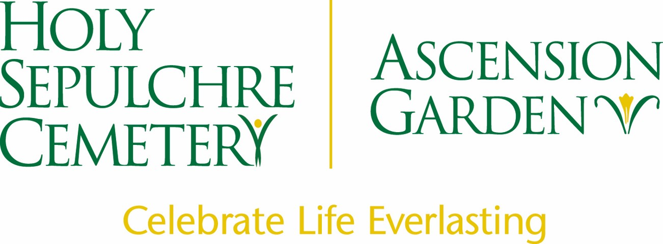

Landscape Technician/ Cemetery Worker

Holy Sepulchre Cemetery in Rochester, NY is looking for hardworking, dedicated ground laborers. Seasonal positions are available. Landscaping experience preferred but not required. Seasonal work is available from May 1st through December 1st depending on the weather.

Job applicants must have a valid New York State driver's license and will be required to pass a pre-employment physical and drug test.

Qualifications:
- Must be reliable and hard working
- Ability to lift 50 lbs.
- Punctual, professional and respectful to visitors
- Positive attitude with the ability to follow direction
- Works well with a team

Job duties include:
- Zero turn mowers
- Spring clean-up, pruning, mulching
- Landscape installation of plant material and pavers.

Compensation:
Seasonal starting rate of $15.50- $18.00/hr.

Benefits include, but not limited to:

Health care coverage, Dental insurance, 403b match & contributions, Paid time off and paid holidays

To apply, please send your resume to Aurora Conti at aurora@holysepulchre.org.

